G.V. VETERANS GOLF
Special Match Report

On Monday 13 May a full team of 36 GVVGA members travelled to Benalla to contest for the Ralph Sneyd Trophy being the North East Zone’s Intra-zone Challenge. This event is decided on the aggregate stableford score of the top 30 players of each team, between the districts of Dalhousie, Goulburn Valley and North East.
The trophy was named to remember the work that Ralph Sneyd did to promote the sport for veteran golfers including the role of president of the Victorian Veteran Golfers Association in 1993 and 1994. We were honoured to have Ralph’s son, Dr Simon Sneyd, who practices and resides in Shepparton, attend to present the trophy to the winning team.
North East used the home ground advantage to record the win with an aggregate of 1002, from GV on 960 and Dalhousie on 951.
Best score for Goulburn Valley was recorded by Rob Frame (Mooroopna) and Ron Smith (Numurkah) both on 38 pts, Ken Harris (Shepparton) and Gary Hopcraft (Hill Top) 37 pts. Down the line balls went to players with 32 pts or more.
Best scores for NE were recorded by R. Forrest (39), D. Comerford (37), M. Tobin (37), R. Baker (36).
Dalhousie had J. Reeves (38), P. Jarvis (37) G. Rowe and G. Wright (36).
Nearest the pin was contested on three greens and the respective winners were: Hole3, 190m; Andy Scott (NE); Hole 8, 123m; Roden Brady (GV); Hole 13, 135m; Ron Smith (GV).
Our next regular event will be at Rich River Golf Club, Moama, on Monday, 20 May, 9.30am assembly, 10am tee.

You are welcome to include the additional information and picture below to complete the report or place it elsewhere in your paper.

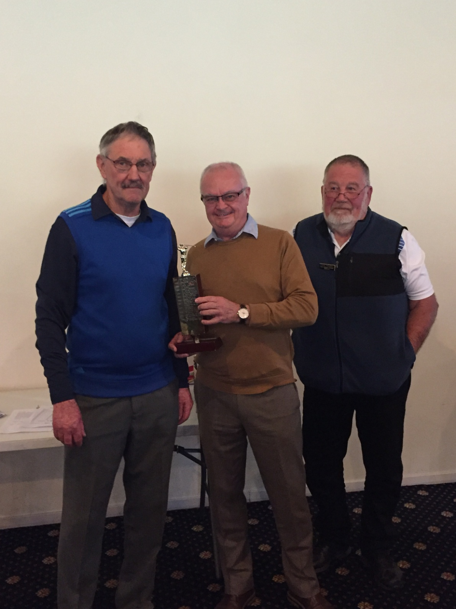
Simon Sneyd, centre, presents the Ralph Sneyd trophy for the Intrazone Championship Team in 2019 to Rob Forrest, left, captain North East District and Paul Hazell, right, president NE District; at Benalla Golf Club on Monday 13 May 2019.

The veteran golfers NE District Championship match is played on rotation annually between Goulburn Valley, Dalhousie and North East districts for the Ralph Sneyd Trophy.
Ralph Sneyd served the veteran golfers as North Eastern Zone Councillor, and President Victorian Veteran Golfers Association in 1993 and 1994.
Ralph was born in 1928 and raised in Brisbane. After schooling he trained as a wool classer and then moved into management roles with Elders and Portland Wool Brokers.
In 1967 he joined the United Nations food and agricultural organisation [FAO] and moved to India for 7 years. He continued with the UN until his retirement in 1983 living in Pakistan, Syria and eventually at head office in Rome for 10 yrs.
He retired to a small property in the Warby ranges to be closer to family. He was still quite young at 57 so he rekindled his love of golf which he had played in Newcastle and Portland before going overseas. He initially played at Wangaratta golf club before moving to Jubilee where he continued to be an active member until his death suddenly aged 73 (2001).

Additional information

